From Throwaway to Sustainable: A New Mindset for These Times

Introduction
Walk into any supermarket in Abuja or Lagos and you’ll see it: products wrapped in layers of packaging, plastic bags handed out freely, and a culture of convenience that rewards speed over stewardship. This “throwaway” mindset isn’t just about plastic straws or shopping bags; it’s a way of life that treats resources, relationships, and even time as endlessly replaceable.
While the modern economy thrives on fast production and instant gratification, the costs are catching up with us. Clogged drainage channels after a heavy downpour in Lagos or Port Harcourt, floating bottles along the Niger Delta, and growing landfill hills outside Abuja are daily reminders that the Earth’s capacity to absorb our waste is finite. The World Bank report, ‘Detox Development: Repurposing Environmentally Harmful Subsidies’, ranked Nigeria, Republic of Congo and India as the top three countries exposed to the most unsafe level of pollution and environmental hazard, accounting for nearly 50% of the global population of people exposed to very unsafe levels of pollution. To secure a livable future, we need a collective shift: from throwaway to sustainable.

1. Understanding the Throwaway Culture
The throwaway culture began as a by-product of industrial progress. In the mid-20th century, single-use plastics and mass production were marketed as symbols of modernity and freedom. Convenience became king.
Plastic Explosion: Plastic production has risen markedly since the 2 million tonnes manufactured in 1950, and is projected to reach 800 million tonnes a year by 2050, less than 10 percent of which is recycled.
Nigeria’s Challenge: Nigeria ranks among the top ten global plastic waste polluters, facing a growing environmental crisis. Each year, the country generates an estimated 32 million metric tons of waste, including an estimated 2.5 million metric tons of plastic, much of which ends up in waterways, streets, and informal dumpsites. Lagos alone produces approximately 13,000 – 15,000 metric tons of solid waste daily.

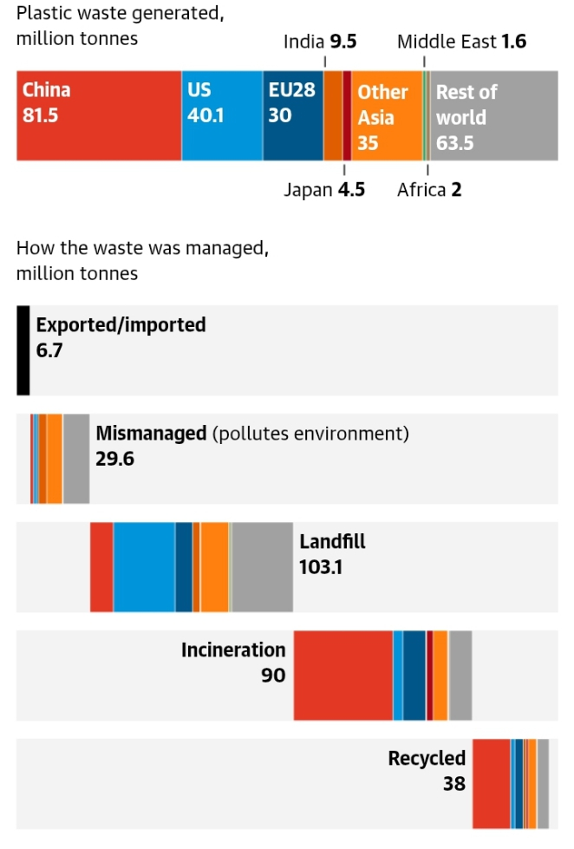
Source: A Nature Portfolio journal, Complexities of the global plastics supply chain revealed in a trade-linked material flow analysis. Note: discrepancies in values are due to rounding during mass balance calculations
Fast Fashion and Electronics: Clothing production has nearly doubled since 2000, while short product lifespans and relentless gadget upgrades create mountains of e-waste. Nigeria imports thousands of tonnes of used electronics annually, much of which ends up in informal dumps like Alaba Market.
But the throwaway mindset is more than consumer habits, it's a way of life. It shapes how we view everything, from quick fixes in politics to fleeting online relationships. When disposability becomes normal, permanence feels old-fashioned.

2. The Hidden Costs of “Cheap and Easy”
Environmental Toll
Discarded plastics clog drainage systems, contributing to urban flooding during Nigeria’s rainy seasons. Microplastics infiltrate soil and rivers, threatening fish stocks, agriculture, and food security.
Economic Burden
The World Bank estimates that inadequate waste management costs Nigerian cities billions of naira annually-including N455 billion in 202X, through cleanup expenses and flood damage. These are funds that could alternatively strengthen health or education systems.
Social and Psychological Impact
A culture of disposability can spill into human interactions, treating commitments, communities, even friendships as replaceable. When everything is “upgradeable,” we risk losing patience, care, and craftsmanship.
Health Hazard
The 2021 World Malaria Report acknowledges that Nigeria remains the most malaria-endemic country in the world, accounting for 27% of cases and 32% of all deaths caused by malaria globally. This reality portrays a drastic evidence of the consequences of waste dumping, an action already normalized in the everyday activities of Nigerians.

3. What a Sustainable Mindset Looks Like
Shifting to sustainability is not merely swapping plastic for paper; it requiresa deeper mental pivot.
Redefine Value
Instead of asking, “How cheap is it?” ask, “How long will it last?” Durability, repairability, and emotional attachment become part of value.
Prioritize Reduction
The first “R” is not recycle, but reduce. Buy less, choose quality, share resources, and question impulse purchases.
Embrace the Circular Economy
Support businesses that design products for reuse, recycling, or composting. In Nigeria, refill-station startups in Abuja and Lagos, as well as initiatives like Wecyclers and RecyclePoints, show how circular models create jobs and reduce waste.

4. Practical Steps for Individuals
- Audit Your Habits – Track what you throw away for a week. Awareness is powerful.
- Reusable Essentials – Carry a water bottle, coffee cup, and shopping bag; many Nigerian cafés now welcome BYO cups.
- Repair and Upcycle – Patronise local tailors and artisans to mend clothes or repurpose fabrics.
- Mindful Diet – Reduce food waste; compost scraps if possible or support community gardens.
- Advocate – Join city cleanups or support policies such as Lagos State’s single-use bag levy.

5. Collective Action: Beyond the Individual
Personal responsibility matters, but systemic change is crucial. Governments and businesses can:
- Enforce bans or levies on single-use plastics.
- Incentivize biodegradable alternatives and local recycling industries.
- Invest in public transit and renewable energy to reduce overall material use.
Nigeria has started to respond. The Federal Ministry of Environment’s National Plastic Waste Management Policy aims to phase out non-biodegradable plastics and expand producer responsibility schemes. When citizens demand accountability, policymakers move faster.

6. Re-imagining Success
A sustainable mindset challenges the myth that progress equals endless consumption.
- Quality over Quantity: Repairable appliances, slow fashion, and community-based agriculture.
- Intergenerational Thinking: Choices today should leave resources for future generations.
- Cultural Pride: Traditional African markets long valued reuse, such as returning bottles for a deposit or reweaving cloth. Reviving these practices is not regression; it is wisdom.

Conclusion: A Call to Our Times
The phrase “a new mindset for these times” is more than a slogan. Climate change, resource scarcity, and economic volatility demand a redefinition of prosperity. Moving from throwaway to sustainable is not about perfection but direction—small, steady choices that build resilience.
Every refillable bottle, every repaired shoe, every policy we champion signals that we refuse to treat the planet or each other as disposable. A point buttressed by the words of Margaret Mead, “We won't have a society if we destroy the environment ”. If enough of us make that shift, sustainability becomes more than a lifestyle trend; it becomes the foundation for a just and thriving future.

